
SCHOOL OF INFORMATION SCIENCE COLLEGE OF COMPUTING, INFORMATICS AND MATHEMATICS INFORMATION SYSTEM MANAGEMENT

IMS566

GROUP ASSIGNMENT:
HOSTEL COMPLAINT MANAGEMENT SYSTEM

CDIM2624ST1

PREPARED BY:
MIKHAEL MIBON (2024788689)
NUR AMIRA BINTI AZHAR (2024776591)
NORDIANA BINTI ABDUL RASHID (2024903465)
PUTERA AZIEM DANIEL BIN ABD RANI (2024764701)
ZAINAL NUR DANISH BIN ZAINAL (2024764829)

PREPARED FOR:
SIR MUHAMMAD ASYRAF BIN WAHI ANUAR

DATE OF SUBMISSION: 2 FEBRUARi 2026

TABLE OF CONTENT

ACKNOWLEDGEMENT 3
REPORT AND USER MANUAL 1
a. Introduction 1
b. GitHub repository link 1
c. ERD 2
d. System requirements 2
e. Installation and setup instructions 4
f. Features and Functionalities 5
g. User Interface Overview 6
h. Navigation guide 7
i. Workflows of specific form 9
j. Detailed instructions on how to use each feature 10
k. Contact information for support 14
l. Conclusion 15
APPENDICES: 12

ACKNOWLEDGEMENT

First and foremost, I am grateful to GOD. With Allah SWT's guidance and blessing, we were given inspiration and motivation that enabled us to complete this assignment. Even though there were some difficulties along the way, it did not bring us down. Instead, it made us stronger to strive harder to achieve what we wanted and led us to where we are at the moment. We are also grateful for the health that Allah has provided us with until the end so that we can become the best version of ourselves and give the best that we can.

Secondly, we would like to thank Dr Muhammad Asyraf bin Wahi Anuar who has
guided us from the beginning until we finally finished this assignment. We are also grateful that my class had Sir as our lecturer because he had taught us everything that we should know and
gave a few tips on completing this assignment. With the help of his teaching, we can fully understand the context and progress of our group assignment.

Lastly, we would like to thank everyone who was involved in helping us in this because
each one of us has taken part in making this assignment a success. From here, we want to
sincerely thank our family and friends for being steadfast pillars of support from the beginning.
Over our journey, their love, support, and understanding have been crucial part for our journey. We appreciate their unwavering support and belief in us during all of our struggles and victories. We sincerely appreciate all of the help and inspiration that we have received.

THANK YOU

REPORT AND USER MANUAL

- Introduction (Brief overview of the application)
The Hostel Complaint Management System is developed with an objective to provide a structured and efficient way for handling student complaints in relation to the hostel management within an educational institution. This will enable students to lodge their complaints through an online application, and at the same time, it will also provide an opportunity for efficient handling and management of complaints by the administration. This will eventually lead to an effective channel for student-hostel management communication.

The application has various important modules such as students, rooms, wardens, and complaints. By incorporating CRUD operations in this application, it ensures effective data management, which is essential for efficient management. Overall, it helps in the digitalization process in relation to hostel management.

- GitHub Repository Link

Our GitHub repository link:
https://github.com/danishzainal/IMS566_hostelcomplaint42.git

- ERD
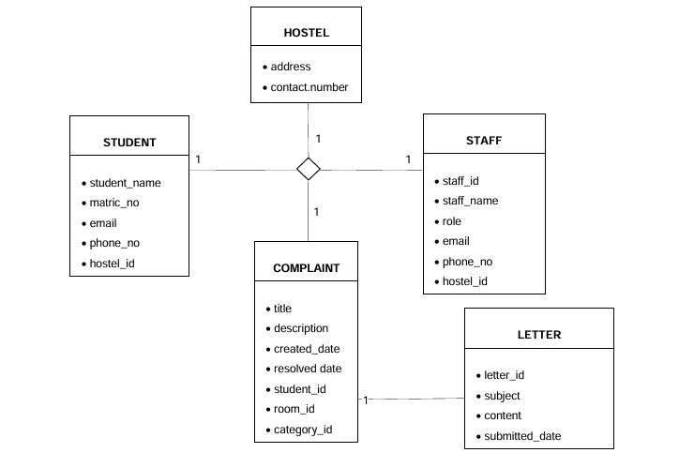

- System requirements
In order to develop the Hostel Complaint Management System, several software and tools will be required for the system to function properly.

1. Operating System
- Requirement: Windows 10 or higher
- Purpose: To have an operating system that is compatible with all the tools being used in the development of the system.

2. Web Server
- Requirement: Laragon (Apache, PHP, MySQL)
- Purpose: To have a local server environment where the system will be deployed for local testing.
3. Database Management System
- Requirement: MySQL (using phpMyAdmin)
- Purpose: To have a database management system where data concerning students, complaints, rooms, and wardens will be stored.

4. Programming Language and Framework
- Requirement: PHP, CakePHP, ReCRUD
- Purpose: To have a framework for developing the system using the MVC approach, where ReCRUD will be used for rapid development of CRUD operations.

5. Dependency Manager
- Requirement: Composer
- Purpose: To have a dependency manager for PHP where several libraries will be required for the system.

6. Code Editor
- Requirement: Visual Studio Code
- Purpose: To have an efficient tool for developing the source code for the system.

7. Web Browser
- Requirement: Google Chrome
- Purpose: To have a web browser where the system will be deployed for testing purposes.

- Installation and setup instructions
Follow these steps to set up the database and application as outlined in your project documentation:
- Initialize Project: Open your command prompt and navigate to the web directory to create the project using Composer:
Bash
cd C:\laragon\www
composer create-project recrud/recrud hostelcomplaint42
Database Configuration:
- Create a new database named hostelcomplaint42 in phpMyAdmin.
- Configure the connection by editing config/app_local.php with the following settings:
  - Host: localhost
  - Username: root
  - Database: hostelcomplaint42
- Import SQL Data: Use the Import tab in phpMyAdmin to upload the hostelcomplaint42.sql file directly into your new database to populate the system tables
- Bake Modules: Generate the backend code for your primary database tables using the following commands in the terminal:
Bash
bin\cake bake all students
bin\cake bake all hostels
bin\cake bake all rooms
bin\cake bake all complaints

- Features and Functionalities
The system centers on four primary modules with full CRUD capabilities as defined in your database structure:

1. User Roles
- Student: Authorized to lodge new complaints, track their specific status (Pending, In Progress, Resolved), and manage their personal profile details.
- Admin/Staff: Responsible for the high-level management of students, room allocations, and updating complaint statuses to ensure resolution.
2. Core Modules (Based on SQL Structure)
Module | Table Name | Functionality
Complaints | complaints | Lodging and tracking issues such as "Wifi not working" (category: ICT).
Students | students | Maintaining records like Matrix ID (e.g., 2024764829), email, and phone numbers.
Hostels/Rooms | hostels, rooms | Tracking room occupancy and levels (e.g., Kolej Jasmine, Room 1E15).
Staff | staffs | Managing roles such as ICT Staff or Facilities Staff to handle specific categories.
Audit Trail | audit_logs | Automatically recording all system transactions for accountability and security.

- User Interface Overview
The Hostel Complaint Management System User Interface (UI) is carefully designed to offer a smooth digital experience that will achieve this by linking the complex internal database management with the average needs of the students. The interface is developed with the CakePHP framework and the Re-CRUD boilerplate in place, and the aesthetic is a professional dark one, which is highly readable and accessible to the Universiti Teknologi MARA (UiTM) student population. The system uses a dual-layered strategy that makes the platform accessible to low-tech users and offers power users the data granularity necessary to be able to practice institutional oversight.

Key Interface Highlights:
Role-Based Adaptation: The design philosophy revolves around role-based access control whereby the interface is designed to dynamically adapt to the group of the user who is logged-in. The system is presented to both students and administrators in a minimalistic and elegant form with a focus on fast actions and powerful administration capabilities, respectively, including system setup and automatic trail of audits.
Student Experience: Once a student has been successfully logged in, there is a simplified workspace, where they can access Lodge Complaint, View History, and Edit Profile. The form used to submit the complaints is programmed in such a way that it is user-friendly through good labeling of the fields, and in-line validation is used to ensure that important information such as room numbers and the type of complaint is collected without overburdening the user.
Administrative Command Center: If it is used in residential colleges such as the Kolej Jasmine, the command center is an administration dashboard that is powerful and data-driven. It offers summarized statistics, including the number of complaints received in total but divided by status and urgency, which enables staff members to set priorities correctly.
Advanced Data Interaction: The UI enables the use of advanced data tables that include in-built search, sorting, and filtering as a means of handling big data. This is necessary to have a track of system-wide transactions in the Audit trail and User logs to ensure that data security standards are high.
Transparency and Control: The system has high administrative control on top of the core modules which is provided on a System Configuration page. This enables authorized people to update organization identity, i.e. names and contact emails (i.e. noreply@codethepixel.com), without having to change underlying source code.
- Navigation guide

Login system
● Go to the: http://localhost/hostelcomplaint/login
● Enter your email and password
●Click login
●Upon successful login, the user will be redirected to the dashboard.

Admin Login
● Admin accesses the system via:
http://localhost/hostelcomplaint/admin/login
● Default login (if seeded)
●Email: admin@localhost.com
●Password: 123456
●The system will redirect the user to the Admin Dashboard.

Student Dashboard
After login, students can access:
●Complaints
●Student Profile
●Logout

Admin Dashboard
After login, admin can access:
●Complaints
●Students
●Rooms
●Wardens
●Logout

Student Features Navigation
File Complaint
1.Click Complaints.
2.Click Add Complaint.
3.Fill in complaint details.
4.Click Submit.

View Complaint
1.Click Complaints.
2.View complaint status.

Admin Features Navigation
●View and manage complaints.
●Update complaint status.
●Manage students, rooms, and wardens.

- Workflows of specific

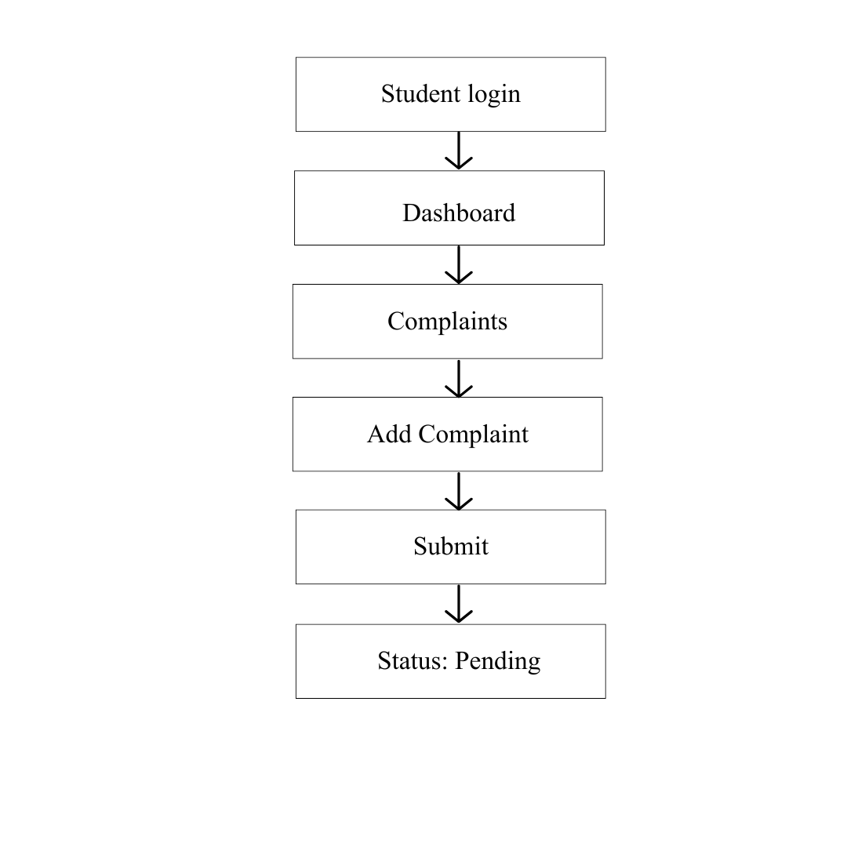

Figure 1: Student Access

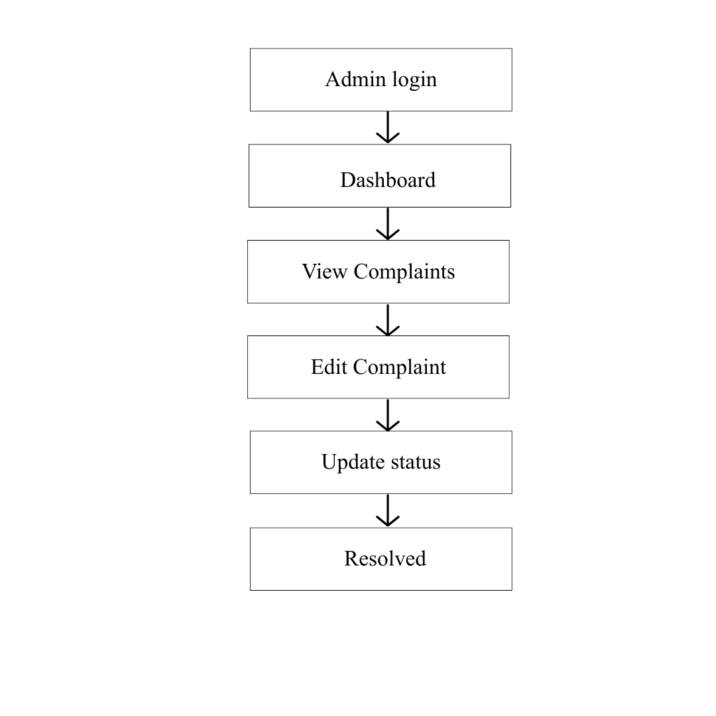

Figure 2: Admin Access

- Detailed instructions on how to use each feature

Login System
● Go to : http://localhost/hostelcomplaint/login
● Enter your email and password
● Click Login
● Upon success, you are redirected to the Student Dashboard

Admin Login
● Admin access the system via
https://localhost/hostelcomplaint/admin/login
● Use default credentials if seeded:
● Email: admin@localhost.com
● Password: 123456
● You will be directed to the Admin Dashboard

Dashboard overview

Student Dashboard:
● Complaints
● Edit profile
● Logout

Admin Dashboard:
● Students
● Wardens
● Rooms
● Complaints

Student features
A. Complaints:
● Click “Complaints”
Add:
● Complaint Type
● Tittle
● Description
● Room
● Date
Click submit
Redirects to complaint list page with confirmation

B. View Complaints:
● Click “View”

You will see a list with:
● Complaint title
● Status: Pending, In-Progress, Resolved

C. Edit
● Click “Edit”
● Change your name, email, or phone number
● Click save

4. Admin Features
A. View and manage complaints:
● Go to complaints page
● You will see all student complaints
● Click edit to: Change the status (Pending - In Progress -
Resolved)
● Click Save

B. Manage Students:
● Go to Students
● Add, edit, or delete student records
● Use search to search and view details
C. Manage Warden:
● Go to Wardens
● Add, edit, delete wardens from the system

D. Manage Rooms:
● Go to Rooms
● Add new rooms or update details
● Useful to track which student is in which room

5. Complaint Status
When a student submits a complaint:
4. Start as Pending
5. Admin review and changes it to In Progress

6. When fixed, admin sets it to Resolved

- Contact information for support

Contact Details of Support:
If you have your opinion on the Hostel Complaint Management, technical support or questions. System, do not hesitate to call in the development group shown below. The system was coded and also recorded by members of the team. The testing had been conducted by the project manager as a quality and functionality assurance.
ZAINAL NUR DANISH BIN ZAINAL
- Role: Developer, Project Manager & Testing Coordinator
- Email: 2024764829@student.uitm.edu.my

PUTERA AZIEM DANIEL BIN ABD RANI
- Role: Developer & Documentation Contributor
- Email: 2024764701@student.uitm.edu.my

NUR AMIRA BINTI AZHAR
- Role: Developer & Documentation Contributor
- Email: 2024776591@student.uitm.edu.my

NORDIANA BINTI ABDUL RASHID
- Role: Developer & Documentation Contributor
- Email: 2024903465@student.uitm.edu.my

MIKHAEL MIBON
- Role: Developer & Documentation Contributor
- Email: 2024788689@student.uitm.edu.my

- Conclusion
In conclusion, the Hostel Complaints Management System was created to be a structured and efficient platform to manage issues or any complaints related to the hostel in an institution. This system allows students to submit complaints online without making students go to the management office to make any complaints. In addition, administrators will monitor, manage and resolve complaints more systematically. Through the implementation of CRUD (Create, Read, Update, Delete) functions, this system will ensure a more accurate data handling system for students, rooms, wardens and complaints.

In addition, this system will improve communication between students and hostel management by causing any complaints received to be communicated transparently and with clear status such as Pending, In Process and Completed. This helps to reduce any delays in handling issues and allows administrators to prioritize complaints more effectively. A centralized database will also succeed in minimizing data redundancy and supporting management in achieving better records.

For future improvements, several improvements can be implemented to increase the efficiency and usability of the system. This includes real-time notification alerts to inform users of complaint updates, a feedback module to assess service quality and mobile-friendly access to allow users to interact with the system anytime and anywhere. This will make it easier for students and staff to access and file any complaints via mobile methods. Overall, the Hostel Complaints Management System supports digital transformation initiatives and contributes to better hostel management services and student satisfaction.

APPENDICES
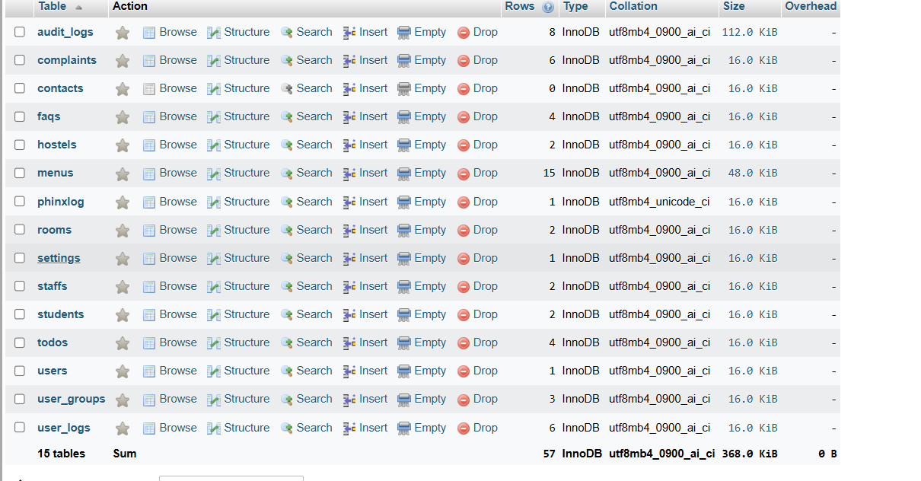
Figure 1

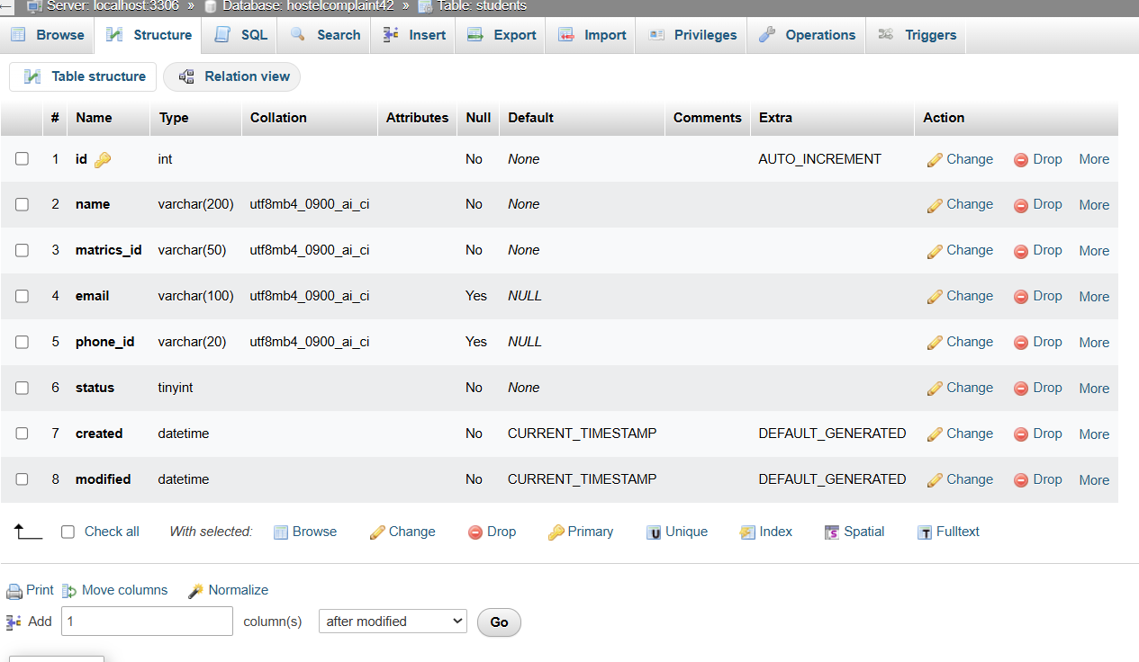
Figure 2

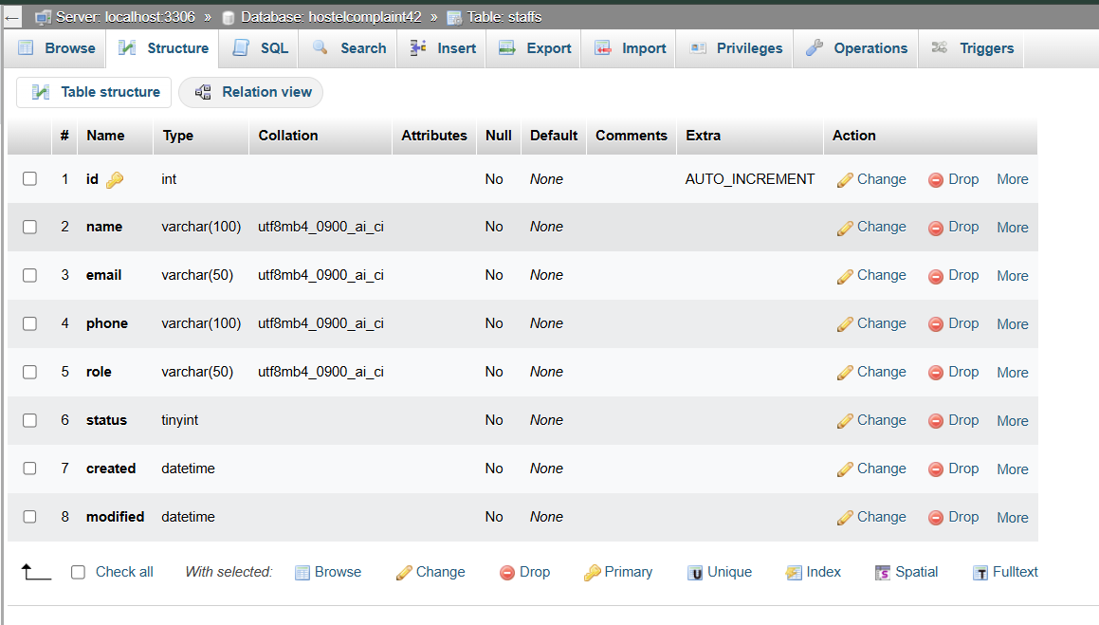
Figure 3

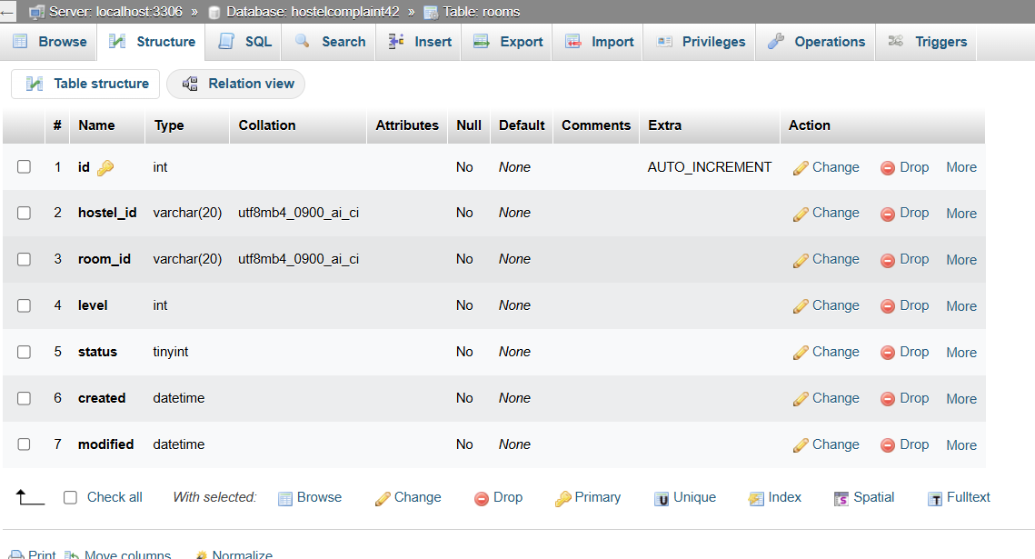
Figure 4

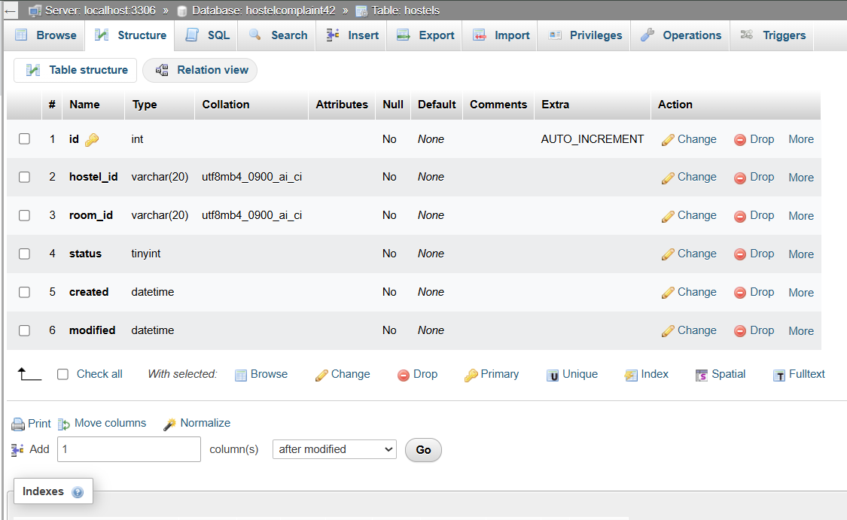
Figure 5

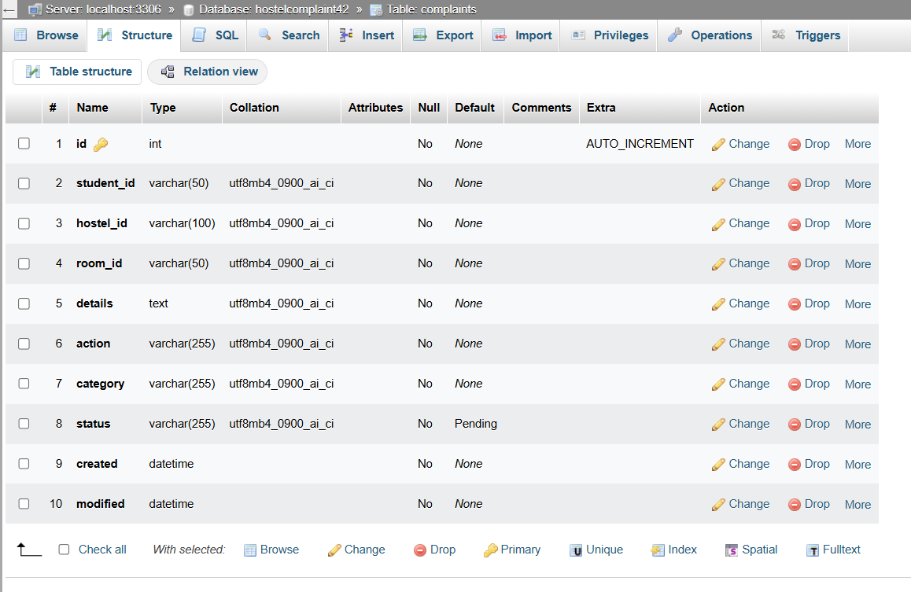
Figure 6

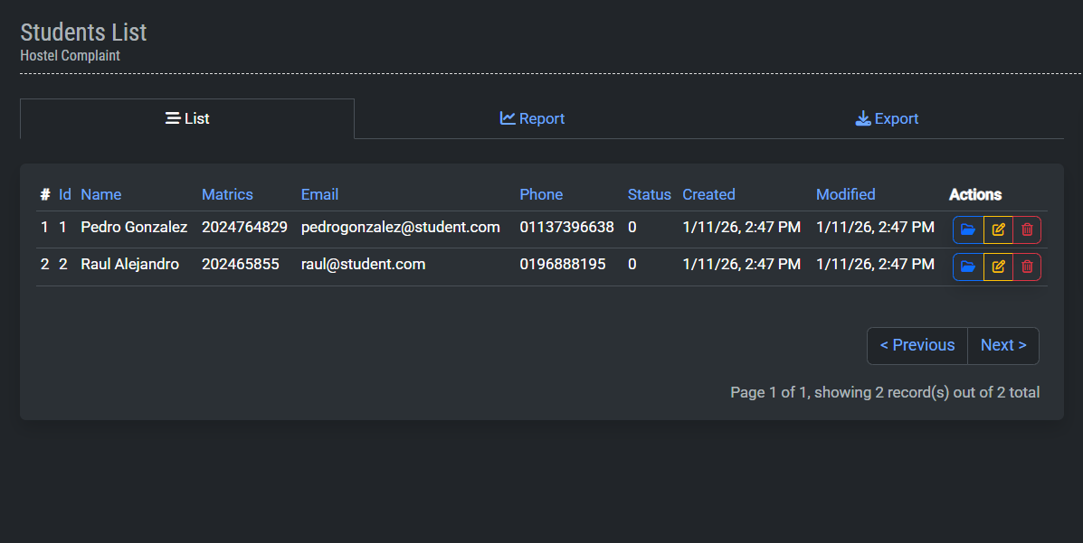
Figure 7

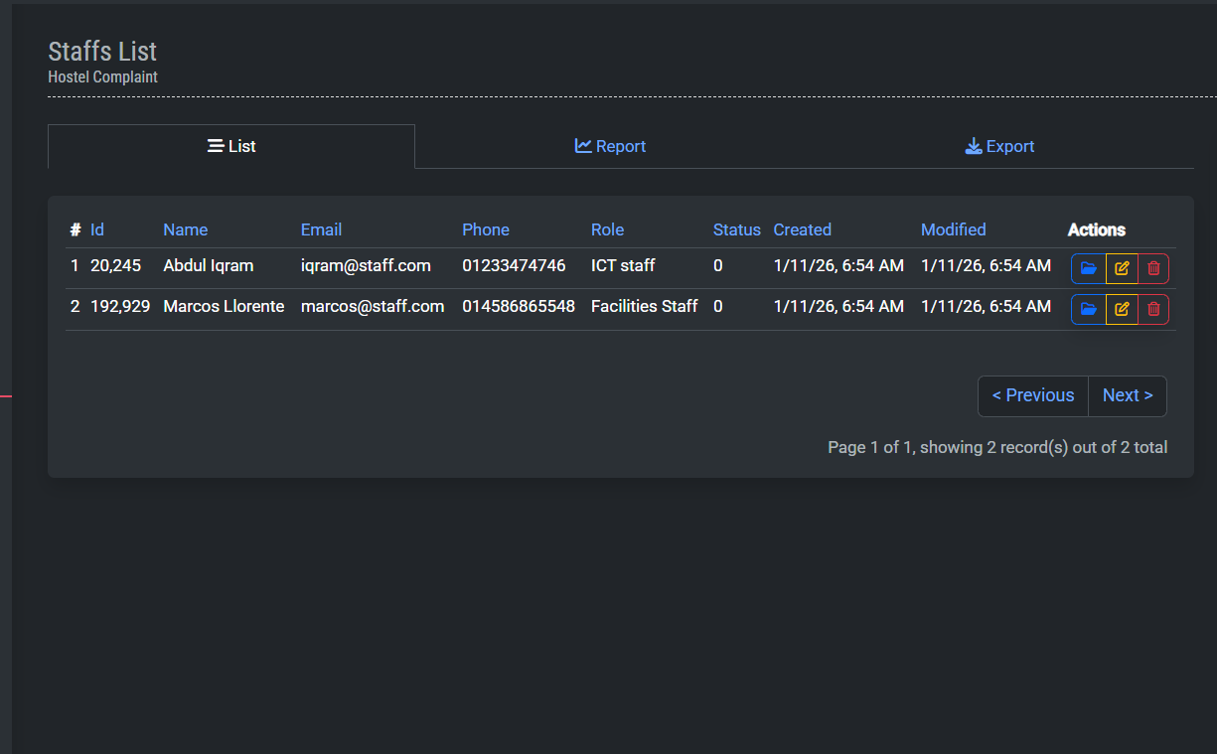
Figure 8

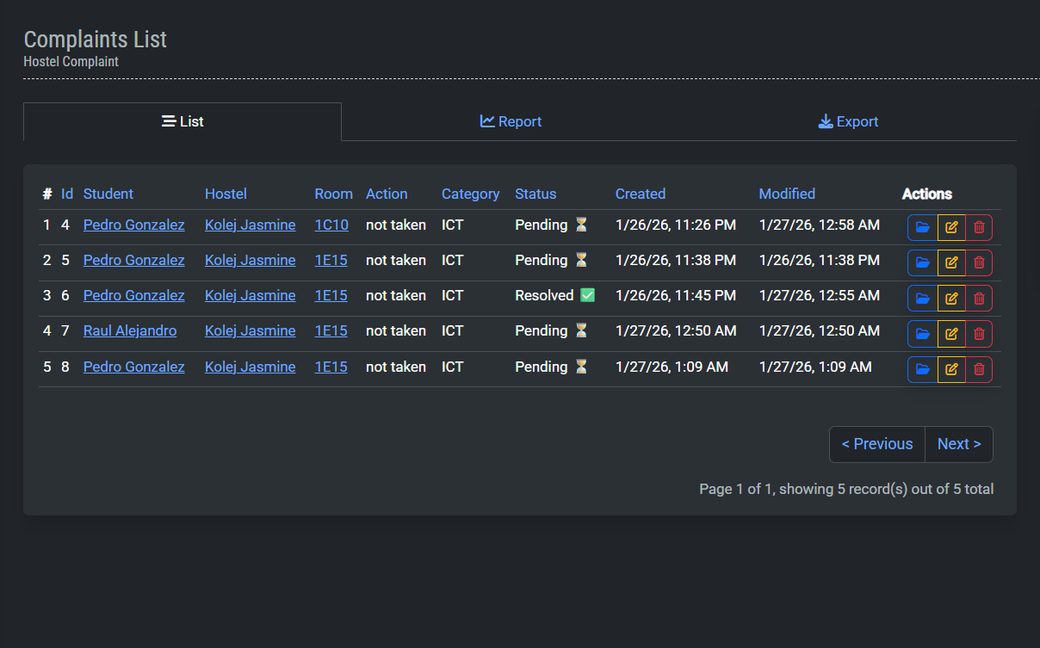
Figure 9

